Finding the Angle for Your Antenna Using a Tilt Plate
By KD7UI
After completing my home brew tilt plate (Al’s design) my next thought was finding an easy way to position the antenna at the right angle on the tilt plate. So that when the antenna is up in the air, vertical, the beam and elements would be horizontal to the ground. Using the trial and error method didn’t excite me.
First here is a picture of my TiltPlate…….
I have about 600 bucks in this job and that’s not counting my time!
Al’s price is fair and anyone that think otherwise, has never built anything, especially to his standard and quality.
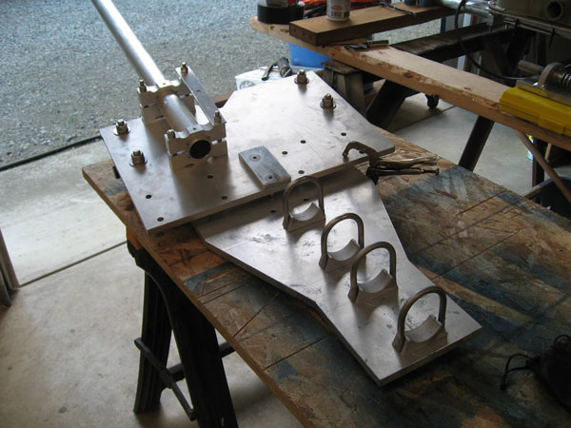

I made up a rough sketch of what I did and it worked extremely well. First time up in the air the antenna was horizontal to the ground and no adjustments were needed.
For parts, I used the aluminum plate off an old circular saw that no longer worked, and I also used a piece of aluminum angle that was bolted to the plate. The size of the plate was about 1/8” X 8” X 12” and all corners were square. You could use plywood too. The size is not that critical but the corners of the rectangle must be square no matter the material used.
I put the tilt plate on a flat surface (table, bench) and installed a short piece of 2” OD pipe. This diameter was the same size as the boom. I used the same U Clamps that would be used later on the antenna boom itself.
After I had the pipe clamped in place I took the aluminum plate and scribed a line in the aluminum. I bolted the angle to the plate and the jig was done. The plate or plywood must be flat on the surface of whatever the tilt plate is on and pushed up tight to the tilting plate that holds the boom, and then make your scribe line. That’s it. Now you have a jig that you can use again and again if you ever have to remove the antenna from the tilt plate.
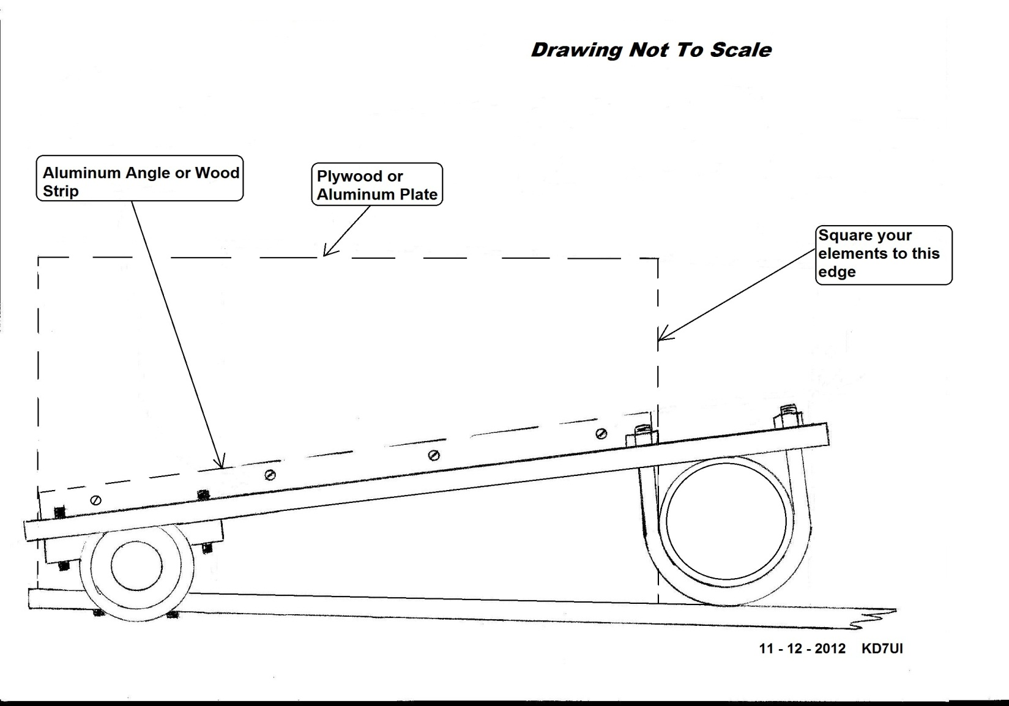
Here are some other pictures that may help and give an overall view:
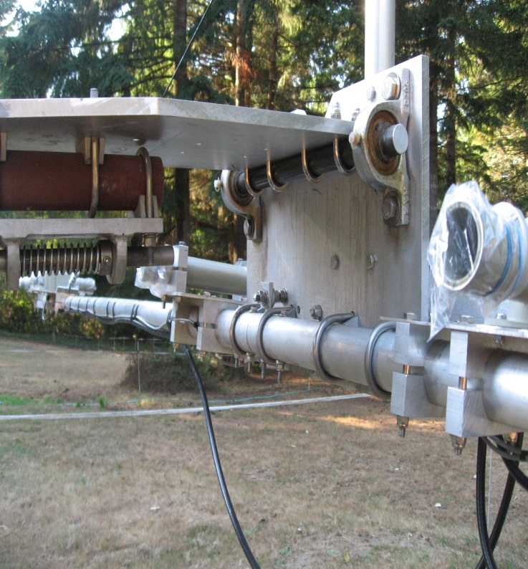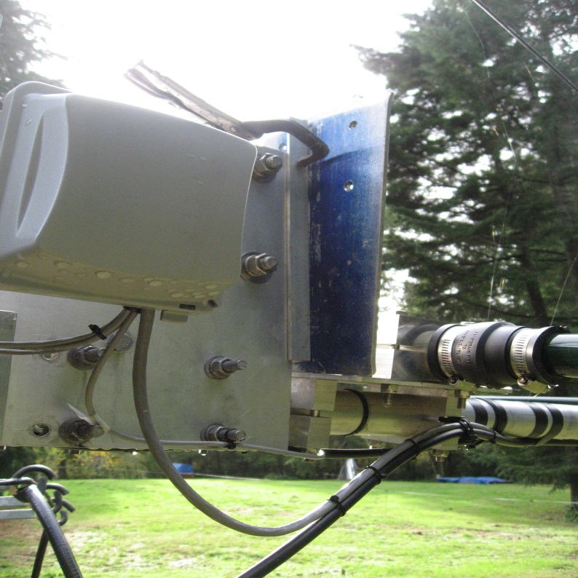
The Boom was adjusted for the proper angle before the SteppIR elements were installed. The picture on the upper right shows the jig clamped to the tilting plate and the bottom of the jig is parallel and tight to the element mounting plate of the antenna. When the antenna is up the elements will be horizontal to the ground.
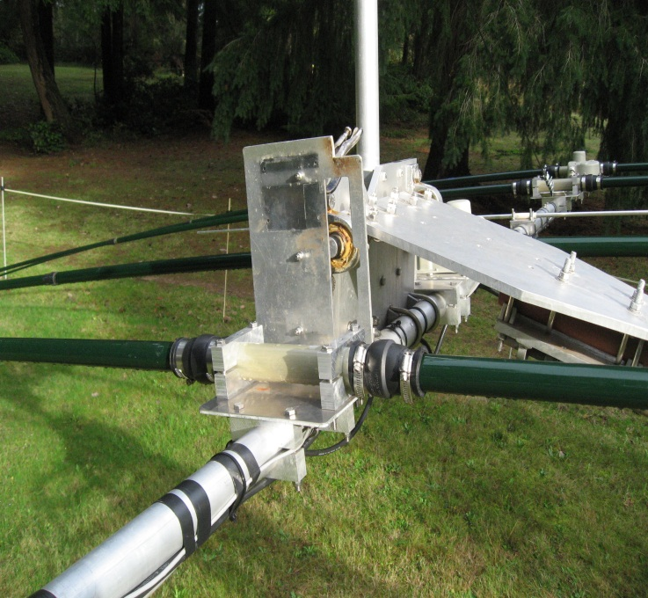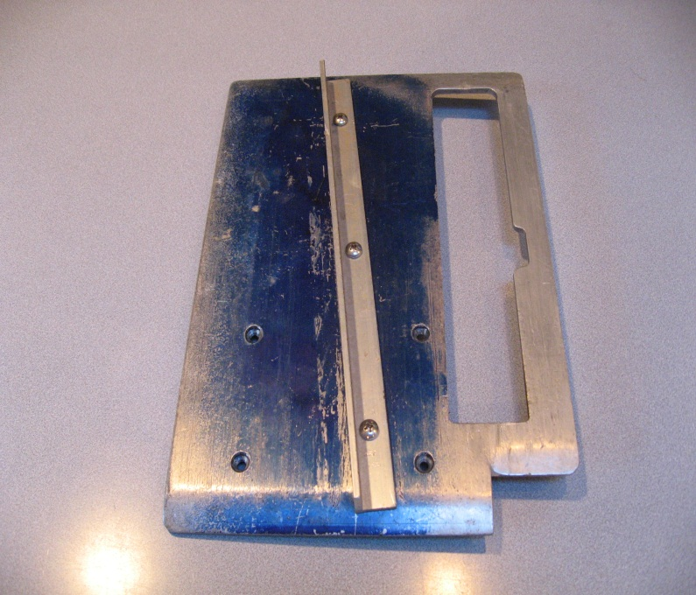
Another view of the jig plate. Jig Plate, nothing fancy but did the job.
Note: The bottom of the jig plate is resting on the aluminum plate that is part of the antenna. The antenna is at the same angle as the bottom of the jig. The jig is clamped to the body of the plate that holds the antenna. I held the jig in place while adjusting the boom for the right angle then clamped the jig to the plate. With the jig plate clamped in place and the bottom of the jig parallel to the elements of any beam antenna you will have the right angle when the tower is vertical.
This method will work with any boom size if the layout steps are done correctly. 73, John KD7UI

